**Supplemental Information**

**Quantifying Drivers of Methane Hydrobiogeochemistry in a Tidal River Floodplain System**

Z. Jason Hou1, Nicholas D. Ward1-2, Allison N. Myers-Pigg1, Xinming Lin1, Scott R. Waichler1, Cora Wiese Moore1,3, Matthew J. Norwood1, Peter Regier1, Steven B. Yabusaki1

1Pacific Northwest National Laboratory

2University of Washington, School of Oceanography

3 Present Affiliation(s): Merrick & Company; University of Colorado Boulder

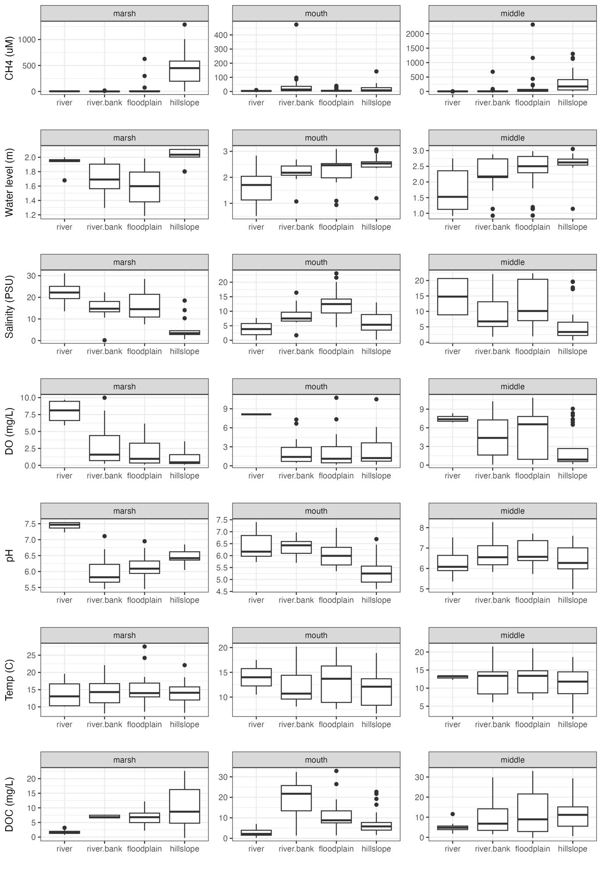Figure S1: Boxplots showing distributions of variables used in Random Forest models.